SUMMARY OF THE PROPOSED PROJECT PLAN FOR THE UPGRADE AND EXPANSION OF UGANDA POLICE F0RCE (UPF) INTEGRATED CLOSED CIRCUIT TELEVISION (CCTV) NETWORK.

Project Title | UPGRADE AND EXPANSION OF UPF CCTV NETWORK
Project Area | UGANDA POLICE FORCE
Scope | Upgrade and expansion of CCTV network to cover KMP, major highways radiating from Kampala, municipalities, key instalations, borders and frontiers
Project Team (E-Poling Taskforce) | AIGP Ochom Edward – D/R,P&D,  SCP Asaba Charles – CI  CP Kugonza Franklyn – LOGISTICS  ACP Mujabwami Ezrah – ICT  SSP Odong Mark – CID  SSP Musinga Norman – T&RS  SP Haguma Jimmy – ICT  SP Ssenyondo Richard – ICT / CCTV (Co-opted).  Mr. Byakutaaga Solomon – CI-TMU  Mr. Ntaro Keneth – CI TMU  Mr. Ayebare Peter – CCU  Ms. Ndagire Carole – FORENSICS
Project Commencement | APRIL 2017
Implementation | UPF and stakeholders

BACKGROUND
In reference to the guidance from the Ministrer of Internal Affairs, Hon. Hajji Jeje Odongo and the Inspector General of Police, the E-policing taskforce was given a strategic mission to fast track a proposal to upgrade and expand the CCTV surveillance Systems with a view of enhancing policing.

The CCTV surveillance system is to be upgraded and expanded within Kampala Metropolitan area focusing on high crime prone areas, as guided by intelligence, and major highways radiating from Kampala capital city for effective traffic and road safety management.

Furthermore, it is to be deployed and implemented in aerial , maritime and motorized resources for purposes of surveillance, tracking and VIP/Key installations protection.

EXPECTED BENEFITS OF THE CCTV UPGRADE AND EXPANSION
- Enhancement of Policing in terms of response time and accuracy; the system will enable Automatic Number Plate Recognition which will aid in the tracking of stolen vehicles, Express Penalty System (EPS) defaulters, Facial Recognition which will aid in the tracking of wanted criminals, suspicious persons and reckless drivers etc.
- Integrated databases / Centre / warehouse; having information in one secure environment allows for better management and monitoring
- Private & secure communications network; this allows for quick and easy information exchange internally with minimal interference
- Private and UPF cloud; this will provide secure storage of information wirelessly
- Faster revenue collection; the system will connect to the Express Penalty System which will enable faster collection of penalty fees and detection of defaulters
- E-learning platform for police staff nationwide; police officers will have easier access to a wealth of online information at their fingertips
- Better engagement with the public particularly those using private CCTV ( better community policing )
- Employment opportunities; the program will equip various Uganda Police staff with more and better skills and create jobs for some members of the public.

ACCOMPLISHED TASKS

Audited existing CCTV surveillance installations and operations

Conducted survey of proposed camera sites nationwide

Conducted market survey on various manufacturers, distributors and integrators of CCTV surveillance systems
- Drawn technical requirements/specifications of the proposed CCTV surveillance systems
- Drawn cost estimates for the proposed CCTV surveillance systems

Ongoing Tasks

Market survey on various manufacturers, distributors and integrators of CCTV surveillance systems
- Engagement with other stakeholders, KCCA, NITA-U, UNRA, UCC and communities
- EXISTING CCTV SURVEILLANCE INSTALLATIONS AND OPERATIONS
Currently, there are 42 UPF sites in KMP with 124 cameras distributed as follows (Annex 1);

S/N | CCTV NETWORK SEGMENT | PTZ | FIXED | TOTAL
1 | Police headquarters | 10 | 28 | 38
2 | City Street surveillance | 19 | 32 | 51
3 | Directorate of Forensics | 0 | 7 | 7
4 | Force Mechanical Workshop | 2 | 23 | 25
5 | Mobile Surveillance (vans) | 4 | 2 | 6
 | TOTAL | 35 | 92 | 127

Table 1: Summary of existing CCTV camera sites.

NETWORK ACCESS TECHNOLOGY

Transmission of video feeds from the camera sites to the CCTV monitoring center is through use of optic fiber by integration to the National Backbone Infrastructure (fibre optic) and wireless access technologies.

CCTV MONITORING AND OPERATIONS CENTER

The monitoring centre is manned by 39 personnel in the following categories

s/no | Category | No. of Staff
1 | Over all Supervisor | 1
2 | Networks | 5
3 | Operations | 2
4 | Operators | 27
5 | Archiving and backup | 1
6 | Production and analysis | 2
7 | Surveillance and monitoring | 1
 |  | 39
Table 2: Current CCTV Staff Distribution

- SURVEY OF PROPOSED CAMERA SITE
Camera site surveys were done in Kampala Metropolitan (KMP), major highways radiating from Kampala to gazette borders and frontiers. For each proposed site geodetic datum were taken to enable the mapping out of proposed camera locations.
- KMP
  - 733 sites were surveyed in KMP (Annex 2)
  - The survey checklist included the following;
    - Distance from the NBI (Government optic fibre cable)
    - Presence of electricity
    - Crime density
    - Security opportunities in place
    - Presence of CCTV camera/ ownership
    - Presence of telecom infrastructure other than optic fibre
    - Geographical coordinates
    - Camera mission indicated in the annex for each camera site
- NATIONWIDE SURVEY ( OUTSIDE KMP )
  - 2000 sites were surveyed outside KMP along major highways, municipalities, borders and frontiers (Annex 3). In addition to the above checklist, the following put into consideration
    - Presence of speed limit signs
    - Line of view of the camera
    - Strategic and high points along highways

CCTV SURVEY OF PROPOSED CAMERA SITES

LOCATION | No. of Sites | No. of Cameras | Remarks
KMP | 733 | 3700 | Fixed and PTZ cameras
Major Installations | 200 | 800 | Fixed and PTZ Cameras
Major Highways | 150 | 400 | Speed cameras and PTZ
Municipalities and major towns | 1843 | 8326 | Fixed and PTZ camera
Boarder Points and frontiers | 57 | 114 | Fixed and PTZ camera
TOTAL | 2,983 | 13,340 | ASSORTED

Table 2 : Representation of the distribution of the 12,540 CCTV Cameras nationwide.

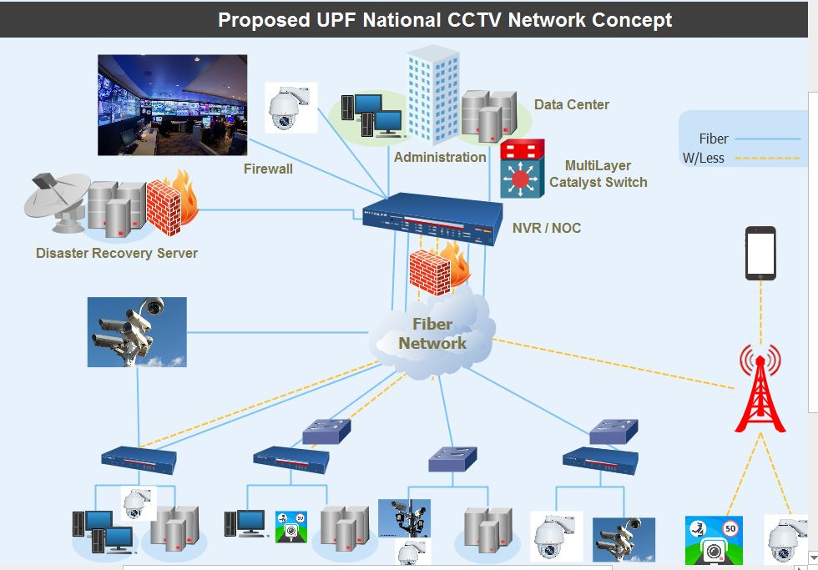
Fig 1: Proposed UPF CCTV Network Concept

MARKET SURVEY ON VARIOUS MANUFACTURERS, DISTRIBUTORS AND INTEGRATORS OF CCTV SURVEILLANCE SYSTEMS

- The market survey is being conducted through consultations with key system vendors such as Bosch Security Systems (Headquarters - Germany). Bosch Security Systems leads in CCTV market share for the Europe, Middle East and Africa (EMEA) region. (http://www.securityinfowatch.com/news/10485302/bosch-tops-in-emea-cctv-market) companies that have implemented major safe city projects and benchmarked on Algerian CCTV surveillance system.
- Amongst others, Bosch introduced to us to Balton CP Uganda, Visual Engineering in Uganda, who made presentations to the team in company of the Bosch Regional Director for Africa and East Asia.
- SANIX technologies Ltd. made a presentation and demonstration on optic fibre installation required for a camera site installation.
- Through emails and telephone communications there are ongoing consultations with AUA and Amiran in Kenya who were also introduced by Bosch as their regional partners.
- Others include Dahua (China) who introduced Integrated Security Systems based in Uganda as their partners and have scheduled a meeting and a presentation to the team,
- ARH (Hungary) who are specialists in the manufacture of speed cameras introduced KPMG Kenya as their regional partners.
- Not one kind or brand of CCTV camera is used in any city or country. Different brands are used to achieve different missions. (http://www.cctvcameraworld.com/cctv-dvr-camera-security-identify/ )
- Further consultations are ongoing with manufacturers , potential integrators, suppliers, local distributors and partners

TECHNICAL REQUIREMENTS/SPECIFICATIONS OF THE PROPOSED CCTV SURVEILLANCE SYSTEMS (Annex 4).

The technical requirements / specifications cover the following
- Building ( Access Control and safety systems inclusive)
- Cameras :
  - Indoor & outdoor dome
  - Indoor & Outdoor PTZ
  - Speed cameras
- Camera site :
- TV wall
- Datacentre
- Workstations

BUDGET:
The total estimated cost for the expansion and upgrade of the CCTV surveillance systems is UGX 301,563,000,000 (Three hundred one billion, five hundred sixty three million Uganda shillings only)
Budget estimates (Annex 5).

RECOMMENDATIONS:

- A building infrastructure to house staff, datacenter, network operations center, CCTV monitoring and surveillance centers and Inter-security Agency Situation Center ( Annex 6 )
- The project can be implemented in three phases :

PHASES | INPUT | COST ( UGX)
Phase 1 | Datacenter, Command and control center, Network operations center, 733 sites in KMP, 50 speed camera highway sites, training for 50 people | 88, 684,356,906
Phase 2 | 2000 camera sites within municipalities and major towns, 50 speed camera highway sites and training for 50 people | 110,731,153,692
Phase 3 | Regional Command Centers | 4,367,767,002

Table 3 (indicate and bold grand totals)

- The procurement process be executed in lots to maximize value for money, project expedition and cost saving as below (Annex 5 )

LOT | PROJECT COMPONENT
Lot A | - Construction of the command and control center building, access control and safety system
Lot B | - Supply and installation of Optic fiber extension ( last mile ) , camera pole, and backed up power
Lot C | - Supply and installation of CCTV cameras, accessories & supply of furniture and fixtures  - Data center and Network Operations ( upgrade and integration of existing system )  - Capacity Building ( training and certifications )Maintenance manual & tools (Operations, maintenance and administration )

Table 5 : Proposed Procurement lot distribution

- Staffing Levels
  - It is proposed to have 1,101 ( One thousand one hundred one ) staff managing the CCTV surveillance operations not limited to Camera operators, network management, supervisors, and analysts working 8 hour a day ( 3 shifts )

S/no | Category | Recommended staff
1 | Over all Supervisor | 1
2 | Networks | 30
3 | Systems Administration and Operations | 20
4 | Operators | 1000
5 | Archiving and backup | 10
6 | Production and analysis | 10
7 | Surveillance and monitoring | 20
8 | Video forensics | 10
 | TOTAL | 1101

  - Considering the scope and magnitude of proposed system and associated manpower staffing, it is proposed that the department is elevated to a division for effective and efficient delivery of services.

